[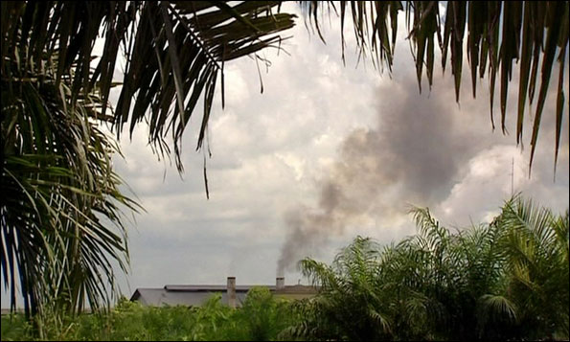](http://www.google.com/url?sa=i&rct=j&q=rainforest+factory&source=images&cd=&cad=rja&docid=6TjQQt23gOJlLM&tbnid=RW845X5AfMd-DM:&ved=0CAUQjRw&url=http%3A%2F%2Fwww.bbc.co.uk%2Fblogs%2Fdaveharvey%2F2010%2F02%2F&ei=ENp9UY8UyMWqAZTkgWA&bvm=bv.45645796,d.aWM&psig=AFQjCNHjvlzYj3IlgO8F5hAx09ZeMTShkA&ust=1367288709891767)[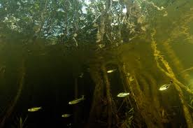](http://www.google.com/url?sa=i&rct=j&q=underwater+in+a+rainforest&source=images&cd=&cad=rja&docid=nVrlS1P7AosoYM&tbnid=j4EQ2JSeejhw_M:&ved=0CAUQjRw&url=http%3A%2F%2Fwww.kqed.org%2Fpress%2Ftv%2Fcousteau%2Famazon%2Fphotos.jsp&ei=SNt9UafsF4StqQGV-oCICg&bvm=bv.45645796,d.aWM&psig=AFQjCNHZwsSw8H5ZEWerN222KaKYw_TXSw&ust=1367289027656429)[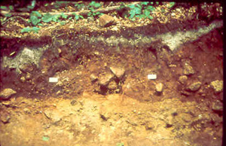](http://www.google.com/url?sa=i&rct=j&q=soil+layer&source=images&cd=&cad=rja&docid=Pb-GQW9yxHQR-M&tbnid=YdfNiPSY9LKtdM:&ved=0CAUQjRw&url=http%3A%2F%2Fwww.hubbardbrook.org%2Fw6_tour%2Fwest-of-6-stop%2Fsoil.htm&ei=7tp9UfnVPM31rAHE7oGIDw&bvm=bv.45645796,d.aWM&psig=AFQjCNGWIdVDKSM6GYjDzZJk40LxOe1JwQ&ust=1367288928362013)[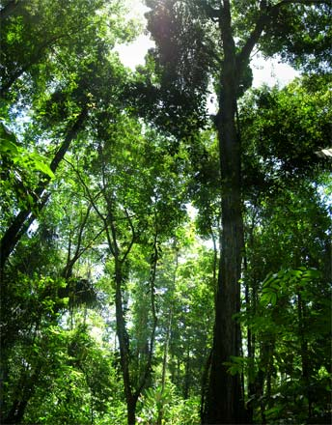](http://www.google.com/url?sa=i&rct=j&q=rainforest+tree&source=images&cd=&cad=rja&docid=MJNGHqueu-9n_M&tbnid=7BJ23Vfmcnm-UM:&ved=0CAUQjRw&url=http%3A%2F%2Fquestgarden.com%2F68%2F81%2F2%2F080725172456%2Fconclusion.htm&ei=Pdl9UYmYJYTMrgHKiYGgCg&bvm=bv.45645796,d.aWM&psig=AFQjCNFSxFMhZiYqWy_sE9T6r1PfZVJMXQ&ust=1367288500318825)[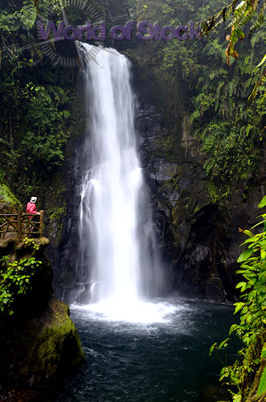](http://www.google.com/url?sa=i&rct=j&q=rainforest+waterfall&source=images&cd=&cad=rja&docid=LCfV2ZabunLUFM&tbnid=phgZdzLMkG8czM:&ved=0CAUQjRw&url=http%3A%2F%2Fwww.worldofstock.com%2Fstock-photos%2Fwet-tourist-watching-a-rainforest-waterfall-in%2FTCA1821&ei=j9l9UcjLD8S7rgHAsYCgAg&bvm=bv.45645796,d.aWM&psig=AFQjCNEXcxoeGT2bDvUAKy7xt3y5OKooOg&ust=1367288575395978)[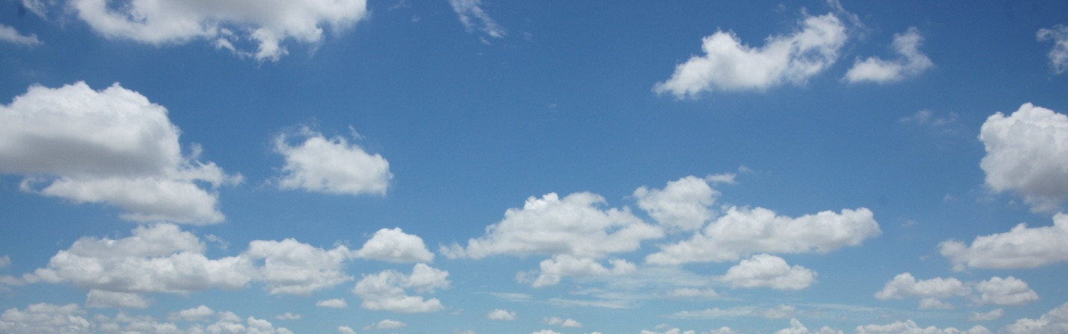](http://www.google.com/url?sa=i&rct=j&q=sky&source=images&cd=&cad=rja&docid=W6f194eOkru6ZM&tbnid=uu0GUYkfTYt5KM:&ved=0CAUQjRw&url=http%3A%2F%2Fwww.allabouthappylife.com%2Fwallpaper%2Fdual_monitor%2Fsky%2Fsky-dual-screen.html&ei=xth9Uez_NNOeqQGxwYH4BQ&bvm=bv.45645796,d.aWM&psig=AFQjCNFGhUXnDfsgPpf_vY9inFqaOgLOUw&ust=1367288385242994)

Diffusion

Cell respiration

Industry that makes combustions of fuels

Plants, algae, animals

Fossil fuels, decomposers, or buried organic carbon

Photosynthesis

Dissolved Co2

CO2 in the atmosphere